CIT438/538
Lab#04: AWS Elastic Load Balancing and CloudWatch

Tools and Materials
- One CentOS VM on the vSphere servers
- AWS CLI

Note: You need to replace words in bold with your information. Questions will be in red. Make sure to show your output.

Part 1: ELB
    - Log in your VM as cit438. Go to the directory where you keep the apache-install script file that you created in Lab 1. Create a load balancer via the following command:

aws elb create-load-balancer --load-balancer-name your_username \
--listeners "Protocol=HTTP,LoadBalancerPort=80,InstanceProtocol=HTTP,InstancePort=80" \
--subnets your_useast1a_subnet_id --security-groups your_sec_grp_id

aws elb create-load-balancer --load-balancer-name hazlettsammy \
--listeners "Protocol=HTTP,LoadBalancerPort=80,InstanceProtocol=HTTP,InstancePort=80" \
--subnets subnet-048109d99999c8dae --security-groups sg-0e8b8b55ca4766f03

What is the DNS_Name of the load balancer?
{
"DNSName": "hazlettsammy-273571731.us-east-1.elb.amazonaws.com"
}

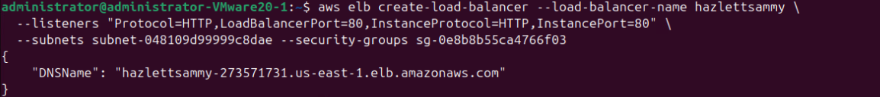

    - Describes the state and properties of load balancers via the following command:

aws elb describe-load-balancers --load-balancer-name your_username
aws elb describe-load-balancers --load-balancer-name hazlettsammy

What is the output?
{
"LoadBalancerDescriptions": [
{
"LoadBalancerName": "hazlettsammy",
"DNSName": "hazlettsammy-273571731.us-east-1.elb.amazonaws.com",
"CanonicalHostedZoneName": "hazlettsammy-273571731.us-east-1.elb.amazonaws.com",
"CanonicalHostedZoneNameID": "Z35SXDOTRQ7X7K",
"ListenerDescriptions": [
{
"Listener": {
"Protocol": "HTTP",
"LoadBalancerPort": 80,
"InstanceProtocol": "HTTP",
"InstancePort": 80
},
"PolicyNames": []
}
],
"Policies": {
"AppCookieStickinessPolicies": [],
"LBCookieStickinessPolicies": [],
"OtherPolicies": []
},
"BackendServerDescriptions": [],
"AvailabilityZones": [
"us-east-1a"
],
"Subnets": [
"subnet-048109d99999c8dae"
],
"VPCId": "vpc-0202cda9d76509845",
"Instances": [],
"HealthCheck": {
"Target": "TCP:80",
"Interval": 30,
"Timeout": 5,
"UnhealthyThreshold": 2,
"HealthyThreshold": 10
},
"SourceSecurityGroup": {
"OwnerAlias": "078646182234",
"GroupName": "usersam2"
},
"SecurityGroups": [
"sg-0e8b8b55ca4766f03"
],
"CreatedTime": "2025-11-02T14:10:33.670000+00:00",
"Scheme": "internet-facing"
}
]
}

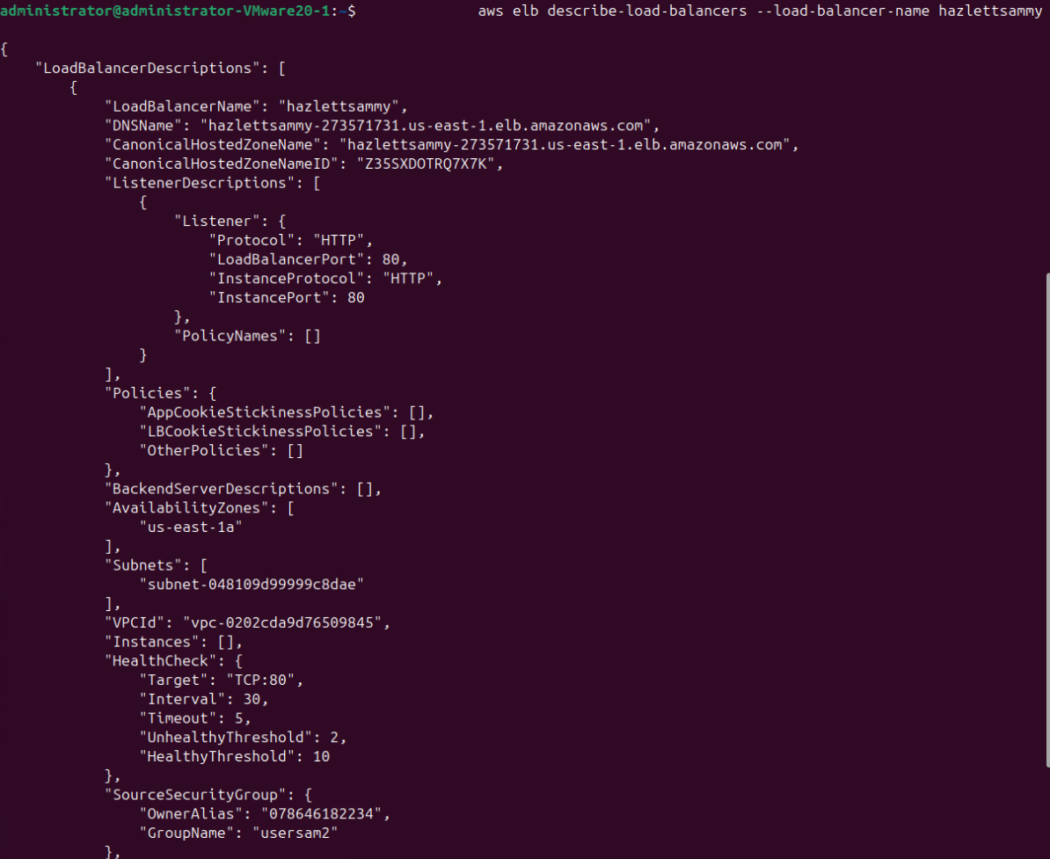
    - Create two EC2 instances with Apache web servers via the following command:

aws ec2 run-instances --image-id ami-013f17f36f8b1fefb --count 2 --instance-type t1.micro --key-name your_key_name --security-group-ids security_grp_id --subnet-id your_useast1_subnet --associate-public-ip-address --user-data file://apache.sh --placement AvailabilityZone=us-east-1a

aws ec2 run-instances \
--image-id ami-013f17f36f8b1fefb \
--count 2 \
--instance-type t3.micro \
--key-name usersam2-key \
--security-group-ids sg-0e8b8b55ca4766f03 \
--subnet-id subnet-048109d99999c8dae \
--associate-public-ip-address \
--user-data file://apache.sh \
--placement AvailabilityZone=us-east-1a

What is the instance id of the first instance? What is the instance id of the second instance?

i-04de6805e6130cfef
i-0b5768b3922241a47

    - Registers instances to the LoadBalancer via the following command:

aws elb register-instances-with-load-balancer --load-balancer-name your_username --instances your_instance_ids
aws elb register-instances-with-load-balancer --load-balancer-name hazlettsammy --instances i-04de6805e6130cfef i-0b5768b3922241a47

What is the output?
{
"Instances": [
{
"InstanceId": "i-0b5768b3922241a47"
},
{
"InstanceId": "i-04de6805e6130cfef"
}
]
}

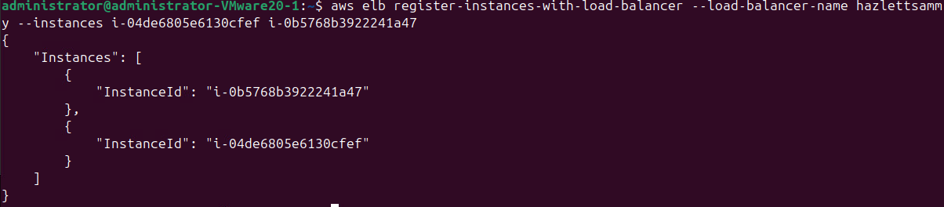

    - Describes the state of the instances via the following command:

aws elb describe-instance-health --load-balancer-name your_username
aws elb describe-instance-health --load-balancer-name hazlettsammy

What is the output?
{
"InstanceStates": [
{
"InstanceId": "i-04de6805e6130cfef",
"State": "InService",
"ReasonCode": "N/A",
"Description": "N/A"
},
{
"InstanceId": "i-0b5768b3922241a47",
"State": "InService",
"ReasonCode": "N/A",
"Description": "N/A"
}
]
}

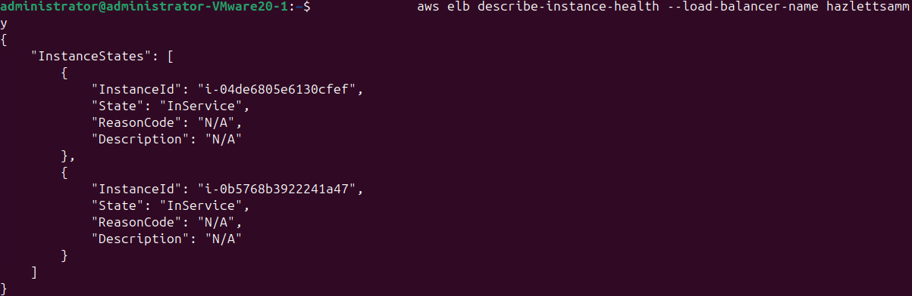

    - Use a browser to access your load balancer to see if it works. Please type the following in the browser: http://dns_name_of_your_load_balancer/
hazlettsammy-273571731.us-east-1.elb.amazonaws.com

You can find dns_name_of_your_load_balancer at step 1. What appeared in the browser?
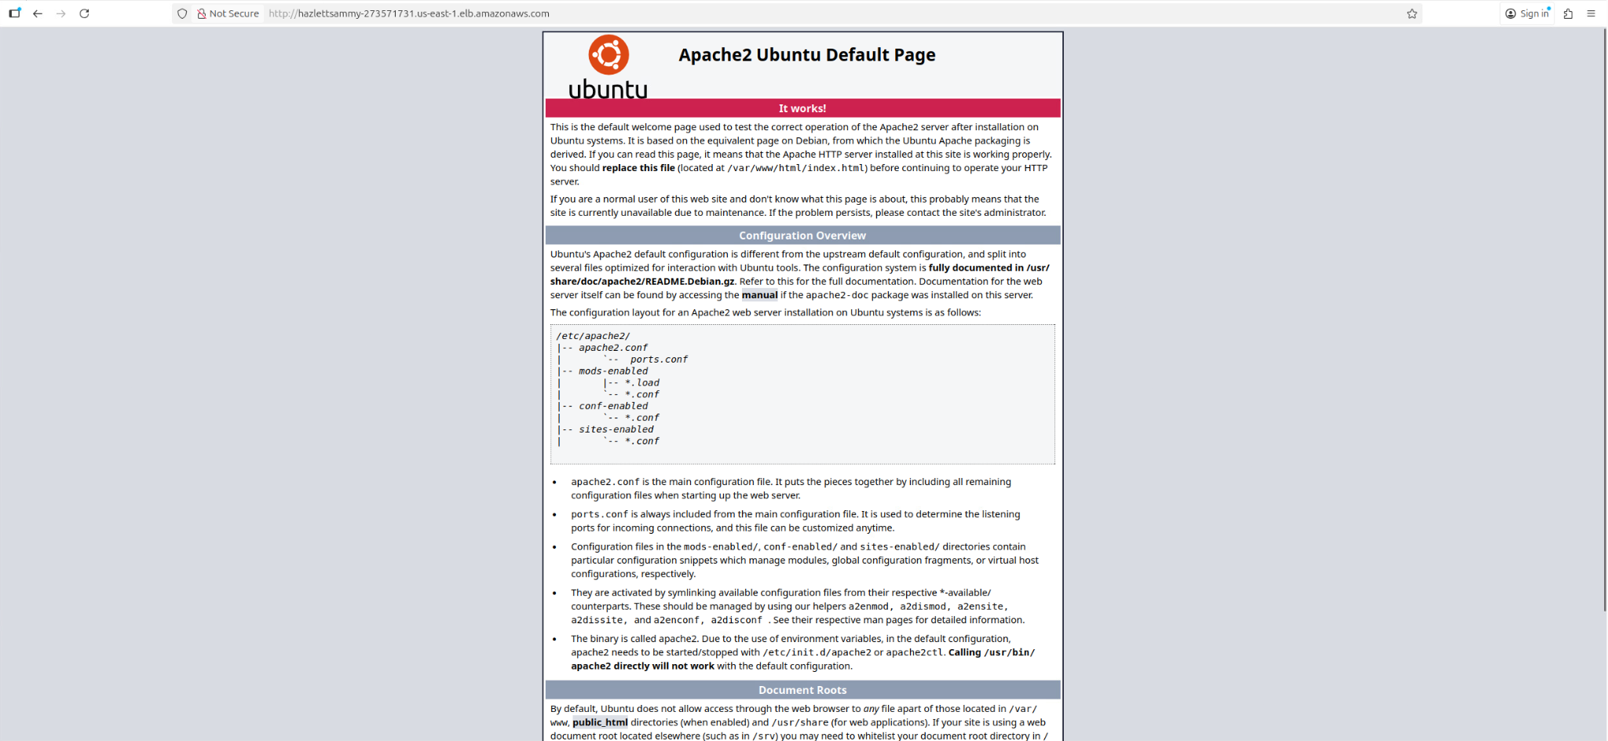

Now let’s modify the home page, /var/www/index.html, for each web server to differ the contents of the home page so that we can know which web server/instance has served the request. Please use ssh to log onto your first instance and switch to root. Modify /var/www/html/index.html to contain only the following:
ssh -i /home/administrator/usersam2.pem ubuntu@54.157.232.163
<html><body><h1>It works!</h1>
<p>The request was forwarded to instance 1.</p>
<p>The request was served by web server 1.</p>
</body></html>
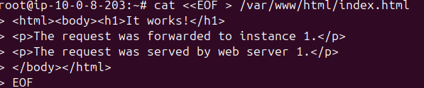
Please use ssh to log onto your second instance and switch to root. Modify /var/www/html/index.html to contain only the following:

<html><body><h1>It works!</h1>
<p>The request was forwarded to instance 2.</p>
<p>The request was served by web server 2.</p>
</body></html>
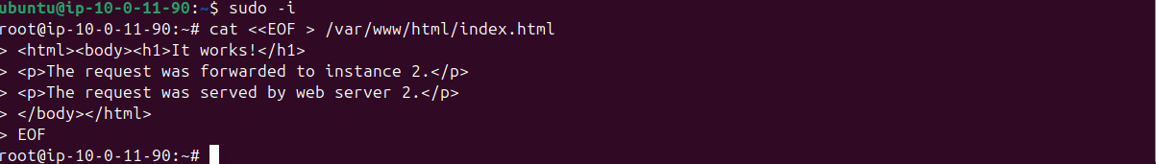
Restart the apache server after updating the index file using the following command on each instance:

apachectl restart

Use your browser to access your load balancer 4 times (you can click the “refresh” button of the browser 4 times to generate 4 requests). Please tell me how many requests were served by web server 1 and how many requests were served by web server 2?
Server 1: 1 time
Server 2: 3 times

Part 2: CloudWatch

    - Start CloudWatch monitoring on both instances via the following commands:

aws ec2 monitor-instances --instance-ids instance1_id instance2_id
aws ec2 monitor-instances --instance-ids i-04de6805e6130cfef i-0b5768b3922241a47

What is the output?

{
"InstanceMonitorings": [
{
"InstanceId": "i-04de6805e6130cfef",
"Monitoring": {
"State": "pending"
}
},
{
"InstanceId": "i-0b5768b3922241a47",
"Monitoring": {
"State": "pending"
}
}
]
}

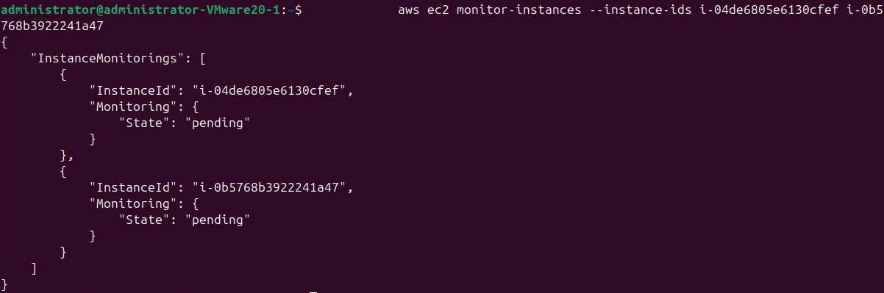

    - Check a list of metrics under the AWS/EC2 namespace via the following:

aws cloudwatch list-metrics --namespace "AWS/EC2"

Did you see the CPUUtilization metric in the output?

{
"Namespace": "AWS/EC2",
"MetricName": "CPUUtilization",
"Dimensions": [
{
"Name": "InstanceId",
"Value": "i-09c1a859cb6acd4ce"
}
]
},
{
"Namespace": "AWS/EC2",
"MetricName": "CPUUtilization",
"Dimensions": [
{
"Name": "InstanceId",
"Value": "i-047c4946d572ff859"
}
]
},

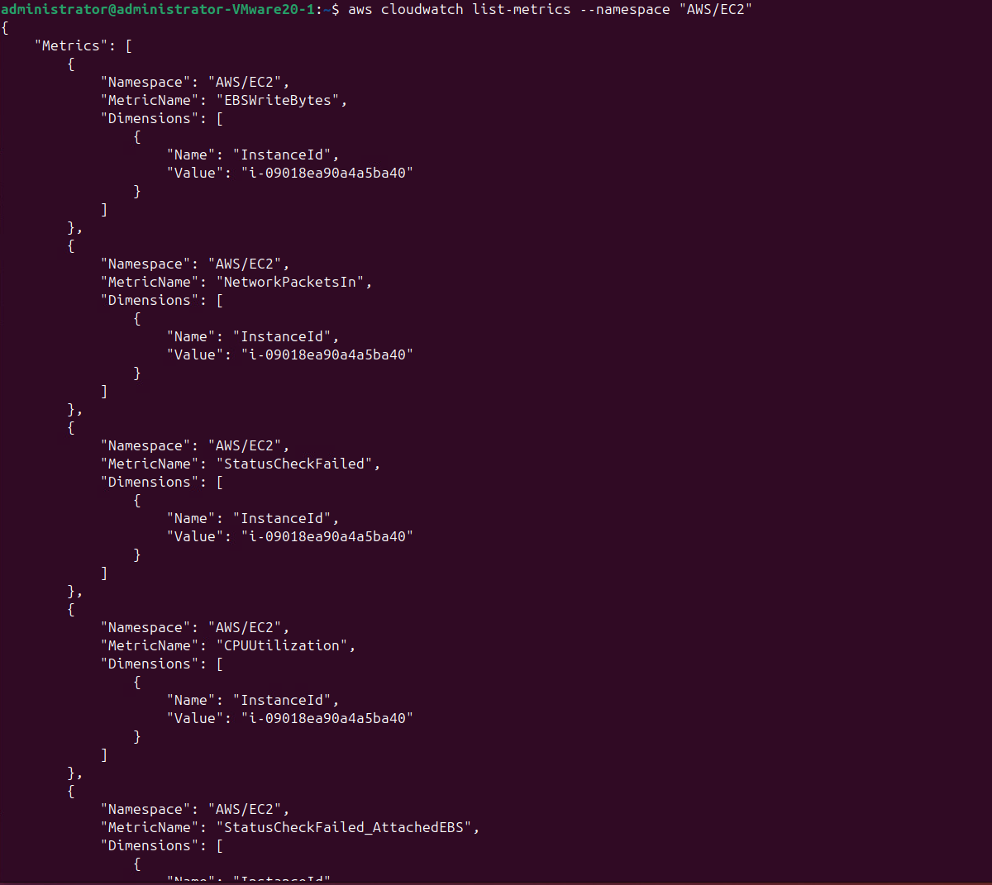

    - Collect the CPU utilization statistics of the second instance via the following commands:
To determine your_start_time and your_end_time, you can run the “date -u” command to get current time in the UTC format. You can set your_end_time to the current time and set your_start_time to your_end_time minus 30 minutes. For example, start_time is 2016-02-14T17:13:00 and end_time is 2016-02-15T17:43:00.

aws cloudwatch get-metric-statistics --metric-name CPUUtilization --start-time your_start_time --end-time your_end_time --period 3600 --namespace AWS/EC2 --statistics Maximum --dimensions Name=InstanceId,Value= your_instance_id

aws cloudwatch get-metric-statistics \
--metric-name CPUUtilization \
--start-time $(date -u -d '30 minutes ago' +"%Y-%m-%dT%H:%M:%S") \
--end-time $(date -u +"%Y-%m-%dT%H:%M:%S") \
--period 300 \
--namespace AWS/EC2 \
--statistics Maximum \
--dimensions Name=InstanceId,Value=i-0b5768b3922241a47

What is the output?

{
"Label": "CPUUtilization",
"Datapoints": [
{
"Timestamp": "2025-11-02T15:00:00+00:00",
"Maximum": 0.0747049155834453,
"Unit": "Percent"
},
{
"Timestamp": "2025-11-02T14:35:00+00:00",
"Maximum": 0.6786562606040041,
"Unit": "Percent"
},
{
"Timestamp": "2025-11-02T14:45:00+00:00",
"Maximum": 0.07486524256338589,
"Unit": "Percent"
},
{
"Timestamp": "2025-11-02T14:40:00+00:00",
"Maximum": 0.0749912510207142,
"Unit": "Percent"
},
{
"Timestamp": "2025-11-02T14:55:00+00:00",
"Maximum": 0.3579992007459704,
"Unit": "Percent"
},
{
"Timestamp": "2025-11-02T14:50:00+00:00",
"Maximum": 1.3275364242806411,
"Unit": "Percent"
}
]
}

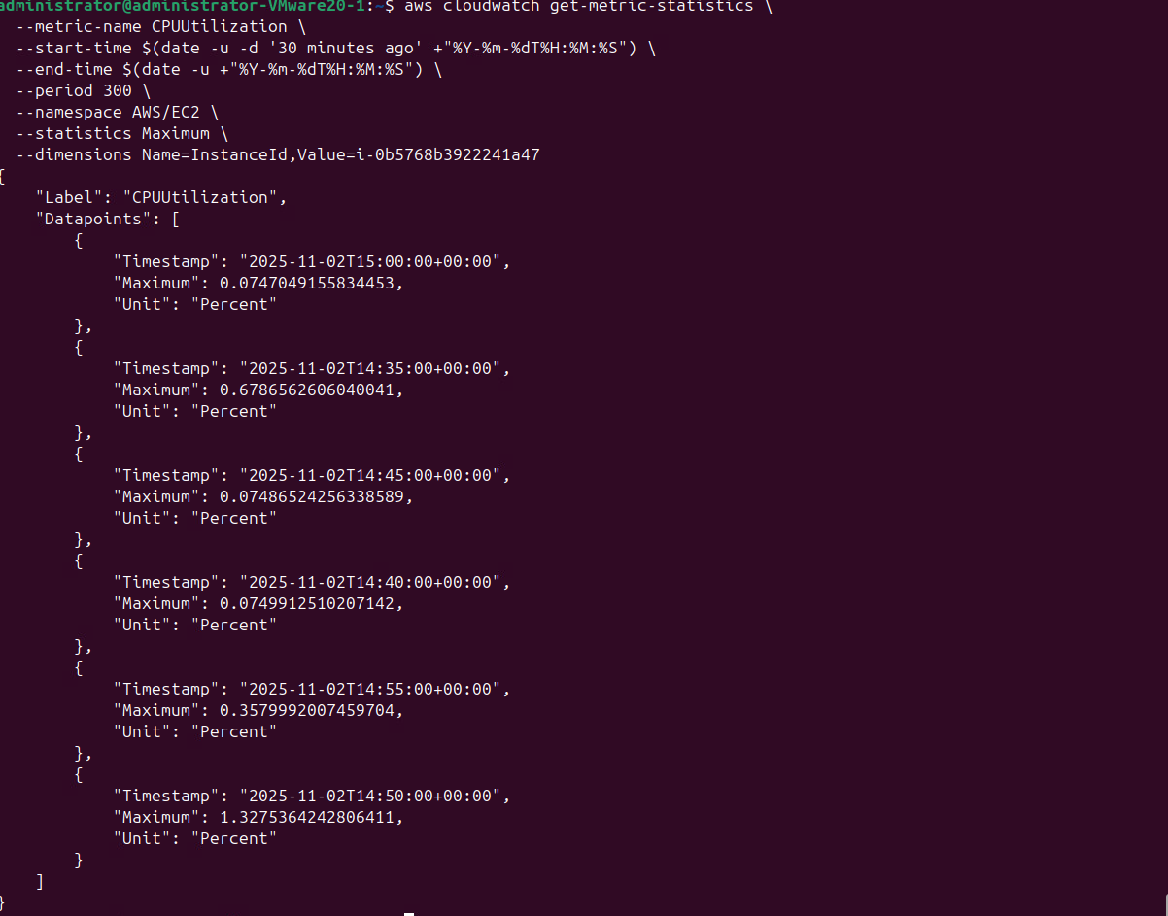
This can be difficult to convert from regular time to UTC, so here is an example of what I ran
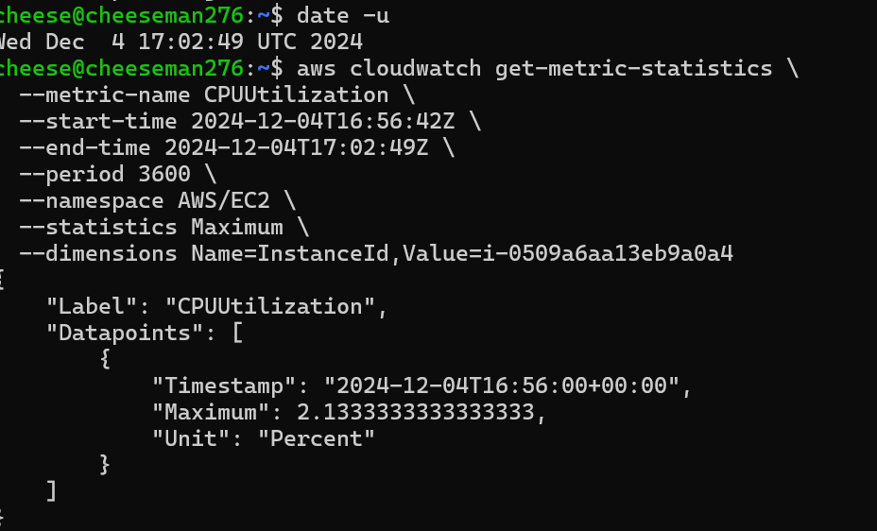

    - Run an Apache HTTP server benchmarking tool, ab, to test your load balancer. For more information on ab, please look at http://httpd.apache.org/docs/2.0/programs/ab.html

ab -n 50 -c 5 http://your_load_balancer_domain_name/
ab -n 50 -c 5 http://hazlettsammy-273571731.us-east-1.elb.amazonaws.com/

Note: if the ab command is not found, please run “apt-get install apache2” on the terminal.
What do –n 50 and –c 5 mean? What is the output?

-n 50 means ApacheBench will send a total of 50 requests to the server.

-c 5 means 5 requests will be sent concurrently (at the same time).

This is ApacheBench, Version 2.3 <$Revision: 1903618 $>
Copyright 1996 Adam Twiss, Zeus Technology Ltd, http://www.zeustech.net/
Licensed to The Apache Software Foundation, http://www.apache.org/

Benchmarking hazlettsammy-273571731.us-east-1.elb.amazonaws.com (be patient).....done

Server Software: Apache/2.4.29
Server Hostname: hazlettsammy-273571731.us-east-1.elb.amazonaws.com
Server Port: 80

Document Path: /
Document Length: 141 bytes

Concurrency Level: 5
Time taken for tests: 0.619 seconds
Complete requests: 50
Failed requests: 0
Total transferred: 20550 bytes
HTML transferred: 7050 bytes
Requests per second: 80.82 [#/sec] (mean)
Time per request: 61.864 [ms] (mean)
Time per request: 12.373 [ms] (mean, across all concurrent requests)
Transfer rate: 32.44 [Kbytes/sec] received

Connection Times (ms)
min mean[+/-sd] median max
Connect: 24 27 1.5 26 31
Processing: 25 28 1.9 27 36
Waiting: 25 28 1.9 27 36
Total: 50 55 3.3 54 67

Percentage of the requests served within a certain time (ms)
50% 54
66% 56
75% 58
80% 58
90% 58
95% 59
98% 67
99% 67
100% 67 (longest request)

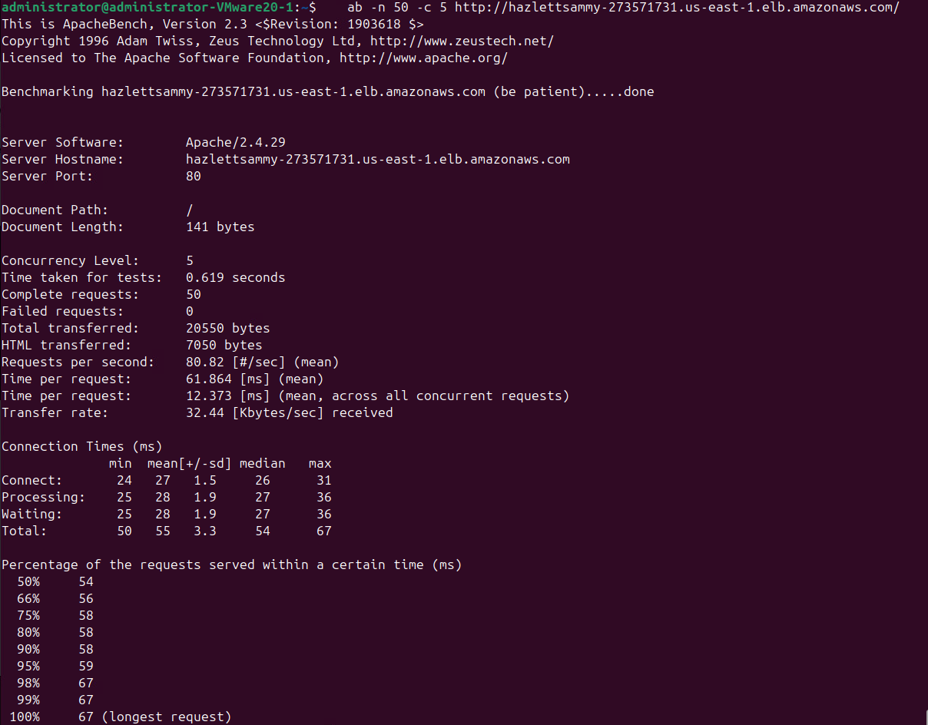

    - Collect the latency metric from the ELB via the following:

aws cloudwatch get-metric-statistics --metric-name Latency --start-time your_start_time --end-time your_end_time --period 3600 --namespace AWS/ELB --statistics Maximum --dimensions Name=LoadBalancerName,Value=your_username
aws cloudwatch get-metric-statistics \
--metric-name Latency \
--start-time 2025-11-02T14:41:19 \
--end-time 2025-11-02T15:11:00 \
--period 300 \
--namespace AWS/ELB \
--statistics Maximum \
--dimensions Name=LoadBalancerName,Value=hazlettsammy

What is the output?
{
"Label": "Latency",
"Datapoints": [
{
"Timestamp": "2025-11-02T14:46:00+00:00",
"Maximum": 0.001417636871337891,
"Unit": "Seconds"
},
{
"Timestamp": "2025-11-02T14:51:00+00:00",
"Maximum": 0.001062870025634766,
"Unit": "Seconds"
},
{
"Timestamp": "2025-11-02T14:56:00+00:00",
"Maximum": 0.001036167144775391,
"Unit": "Seconds"
},
{
"Timestamp": "2025-11-02T15:01:00+00:00",
"Maximum": 0.0009467601776123047,
"Unit": "Seconds"
},
{
"Timestamp": "2025-11-02T15:06:00+00:00",
"Maximum": 0.001715421676635742,
"Unit": "Seconds"
}
]
}

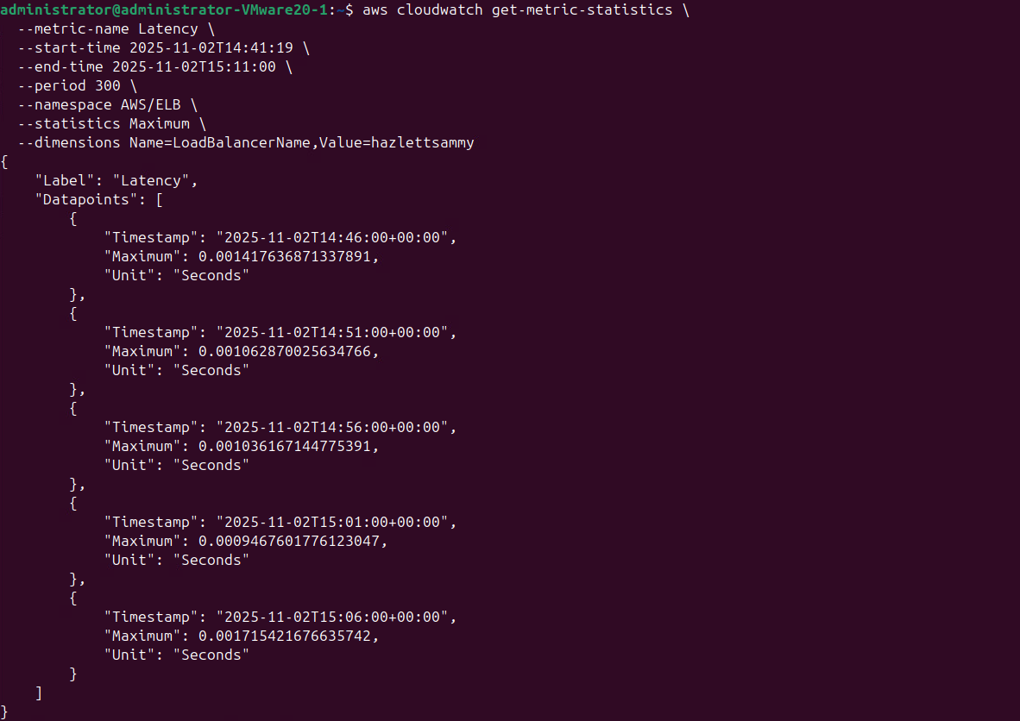

aws cloudwatch get-metric-statistics --metric-name RequestCount --start-time your_start_time --end-time your_end_time --period 3600 --namespace AWS/ELB --statistics Sum --dimensions Name=LoadBalancerName,Value=your_username

aws cloudwatch get-metric-statistics \
--metric-name RequestCount \
--start-time 2025-11-02T14:41:19 \
--end-time 2025-11-02T15:11:00 \
--period 300 \
--namespace AWS/ELB \
--statistics Sum \
--dimensions Name=LoadBalancerName,Value=hazlettsammy

What is the output?
{
"Label": "RequestCount",
"Datapoints": [
{
"Timestamp": "2025-11-02T14:46:00+00:00",
"Sum": 7.0,
"Unit": "Count"
},
{
"Timestamp": "2025-11-02T14:51:00+00:00",
"Sum": 1.0,
"Unit": "Count"
},
{
"Timestamp": "2025-11-02T14:56:00+00:00",
"Sum": 13.0,
"Unit": "Count"
},
{
"Timestamp": "2025-11-02T15:01:00+00:00",
"Sum": 3.0,
"Unit": "Count"
},
{
"Timestamp": "2025-11-02T15:06:00+00:00",
"Sum": 69.0,
"Unit": "Count"
}
]
}

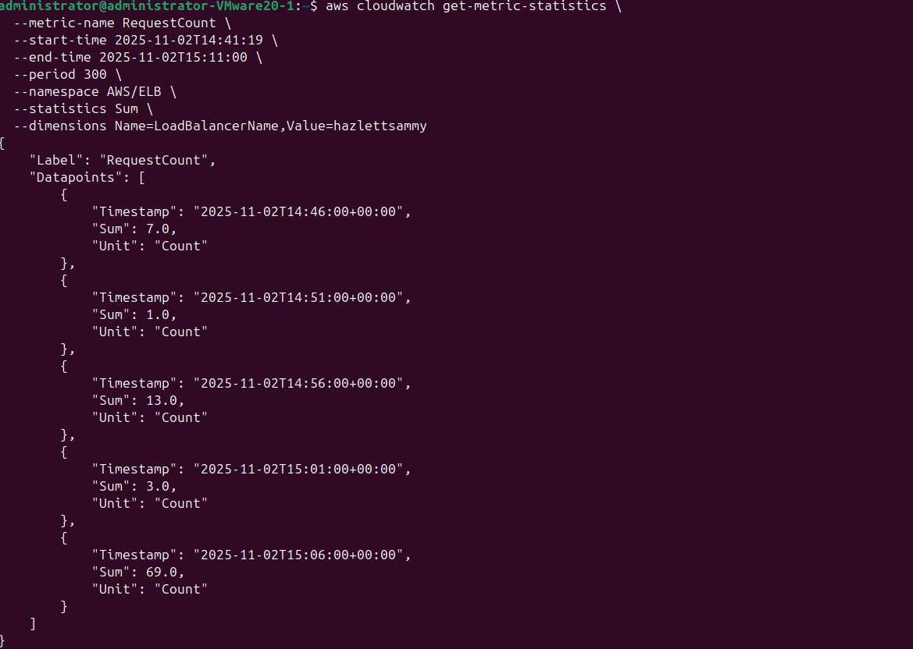

Part 3: Cleanup
    - Deregister instances from the ELB via the following command:

aws elb deregister-instances-from-load-balancer --load-balancer-name your_username --instances instance1_id instance2_id
aws elb deregister-instances-from-load-balancer --load-balancer-name hazlettsammy --instances i-04de6805e6130cfef i-0b5768b3922241a47

What is the output?

{
"Instances": []
}

    - Delete the ELB via the following command:

aws elb delete-load-balancer --load-balancer-name your_username
aws elb delete-load-balancer --load-balancer-name hazlettsammy

    - Terminate your instances. What command did you use? What is the output?

aws ec2 terminate-instances --instance-ids your_instance_id

aws ec2 terminate-instances --instance-ids i-04de6805e6130cfef
aws ec2 terminate-instances --instance-ids i-0b5768b3922241a47
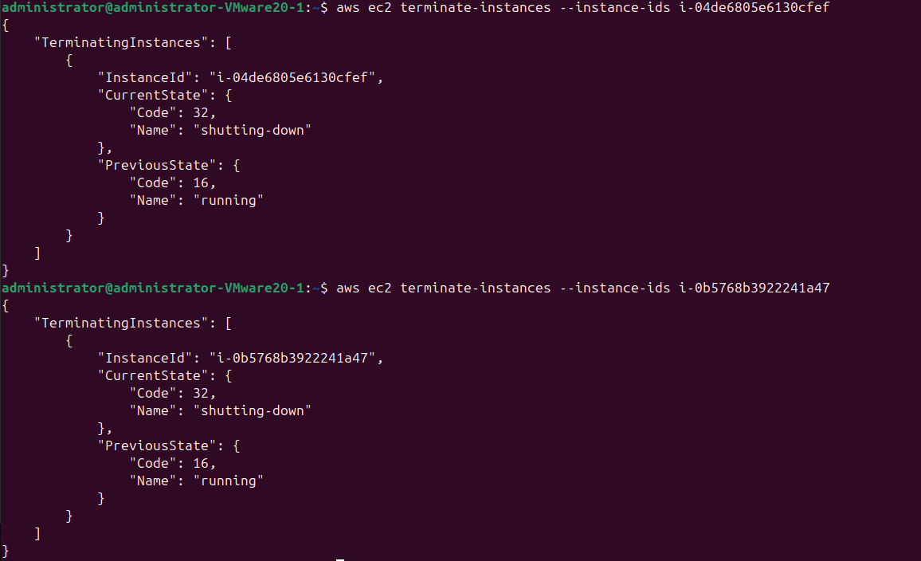

Submission instruction

After completing this work, submit this word document with your answers to the Canvas. In your word document, your answers should be in blue print.

